November 20, 2020

**Employee Spotlight – Meet Michael Herndon**

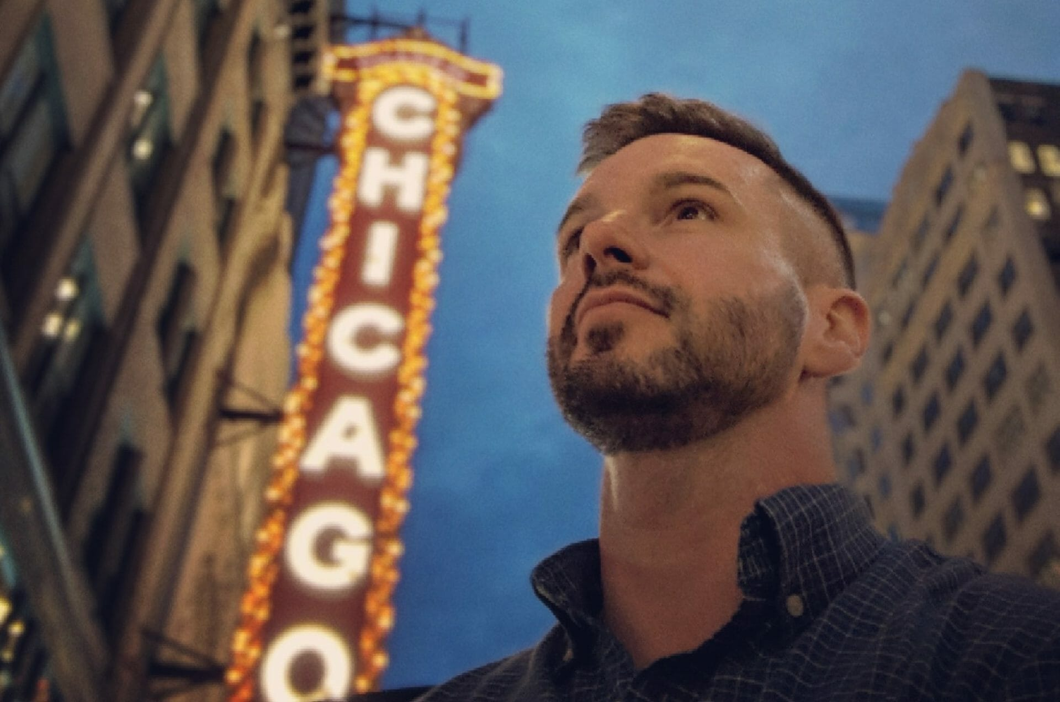

MICHAEL IN CHICAGO FOR CLOUDFIT, SERVING REYES HOLDINGS

CloudFit Software was founded on the backs of visionaries, pacesetters, and people passionate about pioneering new possibilities in software modernization. One such influential member of our core team is a person of firsts. The first official CloudFit employee. The first to often drive customer transformation and build customer trust. The first to give credit to his team and support system. He is an embodiment of our silent deliverable – servant leadership.

We recently sat down with Michael Herndon, Chief Transformation Architect at CloudFit Software, to get the scoop on his role and why he’s passionate about what he does.

**CloudFit –**What does your career background look like?  
**Herndon –**My background includes 25+ years in the IT industry, delivering solutions in both the public and private sectors as a sysadmin, network admin, database architect, solutions architect, and director and owner of my own international consultancy. Most recently, I’ve been fortunate enough to help start CloudFit Software over the last few years as employee #1, the first personal trainer, and the original director of personal training.

**CloudFit –**What does your role entail?  
**Herndon –**I serve on CloudFit’s senior leadership team as Chief Transformation Architect. My day to day includes strategic customer journey mapping, tactical business model design and delivery, defensible Cloud architectures, capability assessments, communications and training and agile management layers for DevSecOps, MLOps and AI Validation.

**CloudFit**– What’s the best thing about your job?  
**Herndon –**The sense of service and gratitude, realizing every successful mission, strategy session and critical decision our clients make have CloudFit’s fingerprints on it as a trusted partner.

**CloudFit –**What has surprised you the most working for CloudFit?  
**Herndon –**What’s surprised me most is how quickly we’ve grown together as a company and the continually great opportunities we have earned to help our neighbors and nation.

**CloudFit –**What’s been one of your proudest moments working at CloudFit?  
**Herndon –**I’m most proud when I see those I coach rise to the challenge of a mission, and when wisdom and courage win out over uncertainty and paralysis.

**CloudFit –**What inspires you?  
**Herndon –**Change, its inevitability and potential. Things in us and all around us are constantly changing. By being mentally prepared for the changes that naturally take place in our lives, we can have a positive attitude about our lives. In fact, we should be able to influence the changes in our lives instead of letting life pull us through the changes.

**CloudFit –**What are five words of advice for others following in your footsteps?  
**Herndon –**All days are good days

**CloudFit –**What do you enjoying doing when you’re not hard at work?  
**Herndon –**I’m a voracious reader and movie lover. I also enjoy hiking and photography

Filed Under: [Uncategorized](https://www.cloudfitsoftware.com/category/uncategorized/)